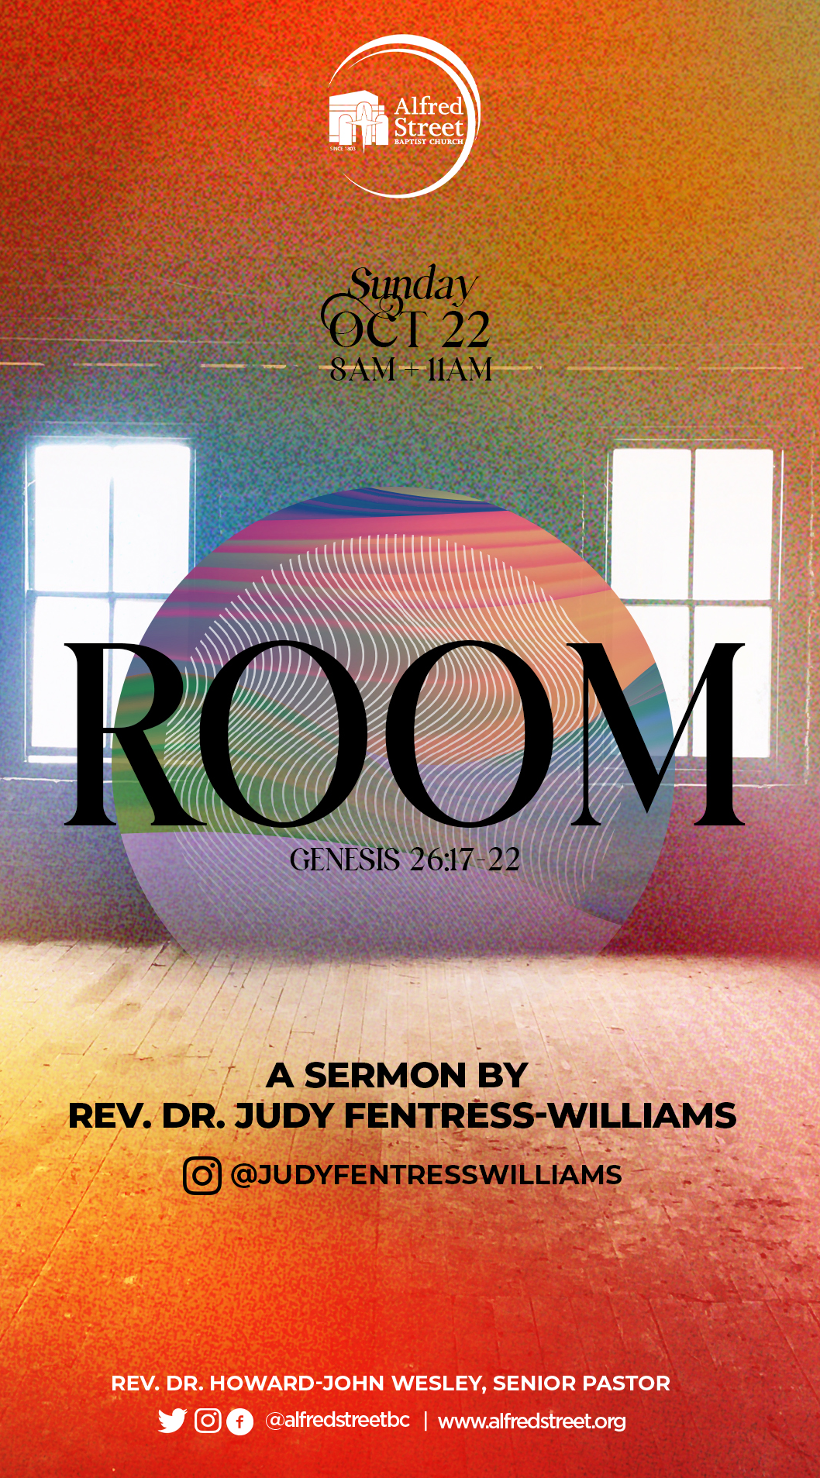
Date: October 22, 2023
Preacher: Rev. Dr. Judy Fentress-Williams Williams
Sermon Title: Room
Scripture: Genesis 26:17-22 (NRSV)

¹⁷ So Isaac departed from there and camped in the valley of Gerar and settled there. ¹⁸ Isaac dug again the wells of water that had been dug in the days of his father Abraham; for the Philistines had stopped them up after the death of Abraham; and he gave them the names that his father had given them. ¹⁹ But when Isaac's servants dug in the valley and found there a well of spring water, ²⁰ the herders of Gerar quarreled with Isaac's herders, saying, "The water is ours." So he called the well Esek, because they contended with him. ²¹ Then they dug another well, and they quarreled over that one also; so he called it Sitnah. ²² He moved from there and dug another well, and they did not quarrel over it; so he called it Rehoboth, saying, "Now the LORD has made room for us, and we shall be fruitful in the land."

SERMON SUMMARY:
Rev. Dr. Judy Fentress-Williams invites us into the life of the Patriarch Isaac as he makes his way into the land given to his father Abraham by God. After the death of Abraham (Genesis 25) and a difficult encounter with the king of the Philistines (Genesis 26:1-16), Isaac moves and settles in the Valley of Gerar. There he begins to restore the wells his father originally created. However, the land of Gerar was inhabited, and Isaac met opposition from the shepherds of the land. The first two wells Isaac restored, Esek (contention) and Sitnah (enmity), were claimed by the shepherds of Gerar. The third well was not. Out of gratitude, Isaac named the third well Rehoboth, which means room.

Using this powerful story of restoration, remembrance, and creating room, Dr. Judy teaches how to structure our lives to receive the fullness of God’s plan for our lives.
- Digging wells reminds us of the need to restore. Isaac works within a predesigned structure to retrieve and restore the legacy of his father’s wells. He teaches us how to recognize what is good and should be saved and what is not and needs to be replaced. Each of us must look around our lives and discern what part of the legacy we have received has merit and should not be discarded, but restored.
- Digging wells reminds us of a need to remember. Isaac has been through a great deal in his life. He has lived through the expulsion of his older brother and his other-mother, Hagar, and he has survived the near sacrifice of his life. Isaac must look back and remember the challenges of his life, so he can do the work of healing and growing stronger. We must also remember those things that bind us and move toward healing, so we can do the greater work of creating life-giving wells.
- As God brings success we need to dig more wells to provide more water. As Isaac experienced success, he needed more wells for his people, animals, and plants. Isaac kept restoring wells until all naysayers disappeared. The final well he restored, Rehoboth, created more room and access to water for Isaac and his people.

KEY POINTS:
- Dr. Judy’s primary points are:
  - Digging wells is an act of restoration.
  - Digging wells is an act of remembrance.
  - We dig more wells because we need more room to grow and expand.

- Though Isaac’s story is not as long or detailed as other patriarchs, his story has import for us.

- As we follow the life of Isaac, we learn important lessons.
  - When God’s provision allows us to obtain good things without asking permission, that is good. Even when we are proud that God’s provision makes a way out of no way, that too is good.
  - But when provision, permission, and pride lead to us believing we are the purveyors of the blessing, or that we deserve the privilege of the blessing, we have forgotten that the blessing was, and will always be the work of God, and not our doing.
  - When provision becomes privilege, it has the potential of becoming a curse.

- Dr. Judy coins the term “well work” to describe the work of restoring, remembering, and creating room. “Well work” is necessary and has to be done to get to the good things that God has for us.

- Like Isaac and the people of his time, most human beings want and work toward living in peace and being unafraid.

GETTING TO KNOW YOU:
- In the Ancient Near East, the presence of a well signaled the possibility of an oasis. In life, we need oasis places. Where are some of the oasis places you go when your journey becomes challenging?

- Dr. Fentress-Williams notes her delight in the shows on HD TV. In part, she appreciates them because in one episode you go from the beginning of a project to its completion. What shows, activities, or other pursuits offer you a sense of completion in a short space of time?

INTO THE BIBLE QUESTIONS:
- Dr. Fentress-Williams notes that whether one lives in Jackson, Mississippi; Flint, Michigan, or Israel/Palestine; the hope is that we will live in peace and have access to that which makes life good. The primary word for peace in the Old Testament (Hebrew) is shalom. This word connotes completeness, welfare, safety, soundness (in body), health, prosperity, quiet, tranquility, and contentment. What surprises you about this definition? How does this change your reading of scriptures which speak of peace? (Click here for a list of scriptures including, shalom .https://www.blueletterbible.org/lexicon/h7965/kjv/wlc/0-1/

- Derived from "Yitzvah," Isaac’s name means "one who laughs or rejoices.” The clue to why Sarah and Abraham name their boy can be found in Genesis 18:12. Does Isaac’s name fit him? Why or why not? What does your name mean? Does it fit you? Why or why not?

LIFE APPLICATION QUESTIONS:
- The act of restoration is often more challenging than rebuilding from scratch. What makes restoration hard work? When is restoration better than a brand-new build? Why should any of us engage in the work of restoration?

- In the text, we learn that the Philistines have “stopped up” Abraham’s wells. Water could not flow into the well until the dirt was cleaned out. What “dirt” is clogging your well? How can you clean it? What filters would you like God to help you develop to keep your well clean?

- In today’s sermon, Isaac surrendered his privilege in naming the wells because “the water was more important than the well.” What is something you might be willing to surrender? What would you gain?

- This sermon reminds us that sometimes the assignment is to go back and remember our pain, so we can recover and heal. Is the process of going back difficult? What have you learned about going back in order to go forward that has served you well?

- God will always provide. God provided for Isaac and his people through the gift of the wells. In your times of challenge, how has God provided for you? The next time you are in a season of difficulty, how does your memory of God’s prior provision assist you?

“CAN I PUSH IT?” QUESTIONS:
- Dr. Fentress-Williams says sometimes we have to clean accumulated dirt out of our personal wells so that God’s water might flow freely. Think about American Democracy. What is the “dirt” that has accumulated there, and how might the church be “Isaac-like” in cleaning it out?

- In this sermon, we hear about the trauma of Isaac’s intended sacrifice (Genesis 22). There are multiple traumas in the story of Isaac (e.g., the trauma of watching his older brother be exiled or the misplaced blessing to Jacob instead of Esau). The religious structures of the world often inflict trauma. When trauma is visited upon the people by the church how can the church be held accountable?

- In Isaac’s time, people knew where the wells were. In our elders’ times, they knew where safe places were because of the Green Book. What is our modern-day Green Book? How do we know where the safe places are as we travel through life’s journey?

FOR INDIVIDUAL OR VILLAGE STUDY

ADDITIONAL QUESTIONS:
- To restore something requires knowing what to preserve and what to discard. What is God calling you to restore?

- There’s a slippery slope from provision to privilege. How do we keep our eyes on the true Provider? How do we avoid moving from greeter to gatekeeper?

- We often exist in the narrow spaces of our own making. These narrow spaces can be due to limited thinking, limited exposure/experience, or fear. What narrow space are you in now? What spaces in your life do you desire God to come in and expand? How might you cooperate with God in this activity?

- In the sermon, Dr. Judy references the movie Room. In the movie, the actual room is a limited, narrow space. The biblical text speaks of Rehoboth, which is a wide, expansive space. God’s desire for us is to live in Rehoboth. How can we move from the narrow spaces of our lives to the wide expansive spaces God desires for us?

ACTIVITY
This sermon reminds us that Isaac does not make a significant contribution to the patriarchy, as does his father (Abraham) or son (Jacob). Many of us live lives of purpose and hope, but like Isaac we do not make significant contributions to the world. However, our lives are important before God. Please list two contributions you have made to others or to the Kingdom that might be invisible, but important to God. Remember, Matthew 25:40 says, “Whatever you did for one of the least of these brothers and sisters of mine, you did for me.”

SPIRIT WORK:
Dr. Judy says it is time for us to “sit with Isaac” and to think about the work necessary to reclaim what has been lost. Think about something you lost that God allowed you to reclaim. What were the steps that you took? What did you learn in that process?

ADDITIONAL RESOURCES
- The Movie, Room
  - https://en.wikipedia.org/wiki/Room_(2015_film)
- The Negro Motorist Green-Book
  - https://www.academia.edu/42607357/The_Negro_Motorist_Green_Book

